## Front End Engineering-II

Project Report

Semester-IV (Batch-2022)

**Social Sphere**

**Supervised By: Submitted By:**

Dr. Vikas Lamba Aadit: 2210990002

Aakanksha: 2210990006

Aakash: 2210990008

Sargam: 2210992259

Shivi: 2210992333

**Department of Computer Science and Engineering**

Chitkara University Institute of Engineering & Technology,

Chitkara University, Punjab

1. **Abstract:**

The abstract provides an overview of the development and implementation of our social media app (SOCIAL SPHERE) aimed at revolutionizing digital connectivity. Through a user-centric approach, the app was meticulously designed to offer a seamless and engaging experience for users of all demographics. Drawing upon extensive market analysis and user feedback, the app incorporates innovative features such as personalized feeds, interactive stories, and robust privacy controls. The report outlines the motivation behind the project, the methodologies employed during development, key features implemented, and future prospects for the app. By prioritizing user satisfaction and technological innovation, the social media app aims to redefine the landscape of digital communication and foster authentic connections in an increasingly interconnected world.

|  |  |  |
| --- | --- | --- |
| **S.No.** | **Topic** | **Page No.** |
| 1 | Abstract | 2 |
| 2 | Acknowledgement | 4 |
| 3 | Introduction | 5 |
| 4 | Problem Statement | 9 |
| 5 | Project Requirements | 10 |
| 6 | Proposed Design and Methodology | 11 |
| 7 | Outputs | 14 |
| 8 | Screenshots | 15 |
| 9 | Results and Conclusions | 17 |
| 10 | References | 18 |

**Table Of Contents:**

1. **Acknowledgement**

We would like to take this opportunity to express our heartfelt gratitude to everyone who has supported and helped during this project.

First and foremost, I would like to thank Chitkara University for providing me with the opportunity to pursue this project and for their guidance and support throughout this project.

I would also like to express my sincere thanks to Mr. Suhaib Khan, for their constant encouragement, guidance, and valuable inputs throughout the project. Their insights and suggestions were crucial in shaping the direction of this project.

Additionally, I would like to thank all the faculty members of the Department of Computer Science for their invaluable support and encouragement throughout the project.

Last but not least, I would like to express my sincere thanks to my team  
members who worked tirelessly on this project. Their dedication and hard work made this project a success.

1. **Introduction**

Social Sphere is a web application built using React.js that offers a seamless and engaging experience for users of all ages. With a sleek and intuitive interface, you can navigate through various features effortlessly. From posting updates and photos to liking, commenting and sharing content, every interaction is designed to be smooth and enjoyable.

It is a dynamic platform designed to redefine the way you connect, share, and discover. With an emphasis on user experience and innovation, our app offers a refreshing approach to digital interaction. Whether you're looking to stay connected with friends, explore new interests, or showcase your creativity, our app provides the perfect space to do so.

**3.1 Background**

Our social media app (SOCIAL SPHERE) was born out of a collective vision to redefine digital connectivity. Fuled by a team of passionate individuals with diverse expertise in software development, design, and community engagement, we embarked on a journey to create a platform that transcends the limitations of traditional social media. Through extensive market analysis and user research, we identified key opportunities to innovate and differentiate ourselves in a crowded landscape. Our app is built upon a foundation of user-centric design principles, ensuring that every feature and interaction is tailored to enhance the user experience. From personalized feeds and interactive stories to robust privacy controls and seamless cross-platform integration, our app offers a comprehensive solution for modern digital communication. As we continue to evolve and grow, our commitment to technological innovation and user satisfaction remains unwavering.

Our platform serves as a virtual gathering place where individuals from diverse backgrounds and perspectives can come together to share their stories, exchange ideas, and build genuine relationships. Whether you're a digital nomad, a passionate hobbyist, or a budding entrepreneur, our app provides a space for you to connect with like-minded individuals, discover new passions, and explore endless possibilities.

**3.2 Objectives**

Social Sphere is designed with several core objectives in mind, each aimed at providing a use and valuable experience for our users.

Firstly, we aim to facilitate seamless communication and interaction between individuals, allowing users to connect with friends, family, and communities regardless of geographical barriers.

Secondly, our app seeks to foster a sense of belonging and community by providing users with a platform to share their interests, passions, and experiences with like-minded individuals. Through features such as groups, events, and forums, we aim to create spaces where users can engage in meaningful discussions and collaborations.

Thirdly, our app prioritizes user privacy and security, ensuring that users have full control over their data and interactions. We implement robust measures to protect user information and mitigate the risk of cyber threats and data breaches. Additionally, we strive to promote digital well-being by encouraging positive and healthy online behaviours, such as mindfulness, empathy, and respectful communication. Our app incorporates features to combat online harassment and bullying, creating a safe and inclusive environment for all users. Furthermore, we recognize the importance of staying updated with the latest trends and developments in technology and social media.

Thus, our app aims to continuously innovate and evolve, incorporating new features and functionalities to meet the changing needs and preferences of our users. Overall, our objectives revolve around fostering genuine connections.

**3.3 Significance**

Social media apps have emerged as transformative tools with significant impact on various aspects of modern society. At their core, these platforms serve as virtual hubs for communication, connection, and collaboration, bridging geographical divides and enabling instantaneous interactions between individuals across the globe. The significance of social media apps lies in their ability to democratize information dissemination, empowering users to share their thoughts, ideas, and experiences with a vast audience. Through user-generated content, these apps facilitate the exchange of knowledge, culture, and creativity, enriching collective discourse and fostering cultural understanding. Moreover, social media apps play a pivotal role in shaping public opinion and influencing societal norms, serving as platforms for activism, advocacy, and social change.

Additionally, social media apps have revolutionized the way businesses engage with customers, offering powerful tools for marketing, customer service, and brand building. From small businesses to multinational corporations, these platforms enable organizations to reach their target audience with precision and efficiency, driving sales, and fostering brand loyalty. However, the significance of social media apps also comes with challenges, including issues of privacy, misinformation, and digital addiction. As such, it is imperative for users, policymakers, and technology companies to work collaboratively to address these challenges while harnessing the immense potential of social media apps to create positive social impact and foster a more connected and inclusive society.

1. **Problem Statement**

In today's digital age, traditional social media platforms often fail to provide users with a safe, inclusive, and fulfilling online experience. Users face challenges related to privacy breaches, cyberbullying, misinformation, and digital addiction, leading to negative impacts on mental health and societal well-being. Existing social media apps often prioritize engagement metrics over user well-being, resulting in an environment rife with toxicity and negativity. Furthermore, many users feel overwhelmed by the sheer volume of content and struggle to find meaningful connections amidst the noise. In light of these challenges, there is a pressing need for a social media app that prioritizes user privacy, safety, and well-being while fostering authentic connections and meaningful interactions. Our social media app seeks to address these issues by providing users with a platform that prioritizes user-centric design, robust privacy controls, and tools to promote positive online behaviour. Through innovative features and a community-driven approach, our app aims to create a safe, inclusive, and enriching online environment where users can connect, share, and thrive.

1. **Project Requirements**

**User Authentication and Registration:** Implement secure user authentication and registration functionality to allow users to create accounts, log in securely, and manage their profiles.

**Profile Management:** Provide users with the ability to customize their profiles, including adding profile pictures, bios, and other relevant information.

**Content Creation and Sharing:** Enable users to create and share various types of content, such as text posts, photos, videos, and links, with options for adding captions, tags, and location information.

**Social Interaction Features:** Implement features that facilitate social interactions, including likes, comments, shares, and direct messaging between users.

**Personalized Feeds:** Develop algorithms to generate personalized feeds for users based on their interests, preferences, and social connections, ensuring relevant content delivery.

**Privacy Controls:** Include robust privacy controls that allow users to manage their privacy settings, control who can view their content, and block or report inappropriate behaviour.

**Real-time Notifications:** Implement real-time notifications to alert users of new likes, comments, messages, friend requests, and other relevant activities on the platform.

1. **Proposed Design and Methodology**

The proposed design and methodology for developing the Social Media app involve a structured approach that encompasses various stages, including requirements gathering, design, development, testing, and deployment. Here's an outline of the proposed design and methodology**.**

**6.1 User Interface Design:**

The user interface (UI) design of our Social Sphere is crafted with meticulous attention to detail, aiming to provide users with a seamless and visually captivating experience. At the forefront of our design philosophy is simplicity and intuitiveness, ensuring that users can navigate the app effortlessly and focus on what matters most: connecting with others. From the clean and minimalist layout of the homepage to the sleek and organized profile pages, every aspect of the UI is thoughtfully designed to prioritize user engagement and ease of use. Our content creation interface offers a user-friendly platform for expressing creativity, with intuitive tools for composing text posts, uploading photos and videos, and sharing links. Clear and recognizable icons guide users through various functionalities, while vibrant colours and visually appealing graphics enhance the overall aesthetic appeal. With a focus on consistency, accessibility, and responsiveness across devices, our UI design sets the stage for a truly immersive and enjoyable social media experience for users of all backgrounds and preferences.

**6.2 File Structure:**

The file structure of Social Sphere is organized into several directories, each serving a specific purpose to facilitate efficient development and maintenance of the application. The 'src' directory houses the core source code of the app, including the 'assets' directory for storing static assets such as images and icons, and the 'components' directory for reusable UI components used across multiple pages. Additionally, the 'data' directory stores static data files, such as JSON files containing user profiles and post data, while the 'pages' directory contains components representing entire pages or routes of the app, such as the Home, Profile, and Explore pages. The main 'App.js' file serves as the entry point of the app, rendering the app's routes and global components, while the 'index.js' file orchestrates the rendering process using React DOM. The 'public' directory contains static assets and the HTML file where the app is rendered in the browser. Lastly, the '.gitignore' file specifies which files and directories should be ignored by version control, while 'package.json' contains metadata and dependencies for the project, and 'README.md' provides documentation and an overview of the project. This structured file organization streamlines development, enhances collaboration, and ensures maintainability of our social media app.

**6.3 Algorithms Used:**

When developing a web application using React.js for the frontend, HTML for markup, and CSS for styling, the algorithms used typically focus on the logic and functionality of the application rather than traditional algorithms like sorting or searching.

1. **State Management**: React applications often utilize state to manage data and application state changes. Algorithms for state management involve deciding how to structure and update state efficiently to reflect changes in the UI and user interactions. This may involve using techniques such as immutable state updates, state normalization, or state machines to ensure predictable behaviour and maintain application integrity.
2. **Component Lifecycle:** React components have lifecycle methods that are called at various stages of a component's lifecycle, such as when it is mounted, updated, or unmounted. Algorithms for component lifecycle management involve deciding how to handle side effects, perform asynchronous operations, or optimize rendering performance within these lifecycle methods.
3. **Virtual DOM Diffing:** React uses a virtual DOM to efficiently update the actual DOM based on changes in component state. The reconciliation algorithm, also known as virtual DOM diffing, compares the current virtual DOM tree with the previous one and computes the minimal set of changes needed to update the actual DOM.

**6.4Methodology:**

The methodology adopted for the development of our social media app (SOCIAL SPHERE) was guided by a systematic and iterative approach aimed at delivering a high-quality, user-centric product. Beginning with a thorough requirements analysis phase, we conducted stakeholder interviews, market research, and competitor analysis to identify key features and functionalities essential for meeting user needs and expectations. With a clear understanding of the project requirements, we selected a robust technology stack comprising React.js for the frontend, Node.js for the backend, and MongoDB for the database, aligning our choices with the project's scalability, flexibility, and performance goals.

During the design phase, we prioritized UI/UX design, leveraging wireframing and prototyping techniques to create intuitive and visually appealing interfaces. User feedback and usability testing informed iterative design iterations, ensuring an optimal user experience. The development process followed an Agile methodology, allowing for flexibility and adaptability to changing requirements. Tasks were planned, assigned, and tracked using project management tools, enabling efficient collaboration and progress monitoring. Throughout implementation, we tackled challenges head-on, incorporating feedback from stakeholders and users to refine features and address issues promptly.

1. **Outputs**

The output of our social media app (SOCIAL SPHERE) encompasses a wide range of user interactions, features, and functionalities aimed at providing a rich and engaging user experience. Here are some key outputs or outcomes users can expect from our social media app:

* **User Profiles**: Users can create personalized profiles with profile pictures, bios, and other relevant information.
* **Content Creation**: Users can create and share various types of content, including text posts, photos, videos, links, and polls.
* **Social Interaction:** Users can engage with content through likes, comments, shares, and direct messages, fostering meaningful connections and conversations.
* **Discovery and Exploration:** Users can discover new content, users, and communities through personalized feeds, trending topics, and recommendations.
* **Notifications:** Users receive real-time notifications for likes, comments, mentions, and other relevant activities, keeping them informed and engaged.
* **Privacy and Security:** Users have control over their privacy settings, allowing them to manage who can view their content, interact with them, and access their personal information.
* **Search and Discovery:** Users can search for specific content, users, or topics of interest, enhancing content discoverability and user engagement.
* **Customization and Personalization:** Users can customize their app experience by following specific topics, users, or communities, creating a personalized feed tailored to their interests.
* **Community Engagement**: Users can join groups, participate in discussions, and attend events, fostering a sense of belonging and community within the app.
* **Content Moderation**: The app employs content moderation algorithms and community guidelines to ensure a safe and respectful environment for all users, minimizing the presence of spam, hate speech, and other harmful content.

1. **Some Screenshots**

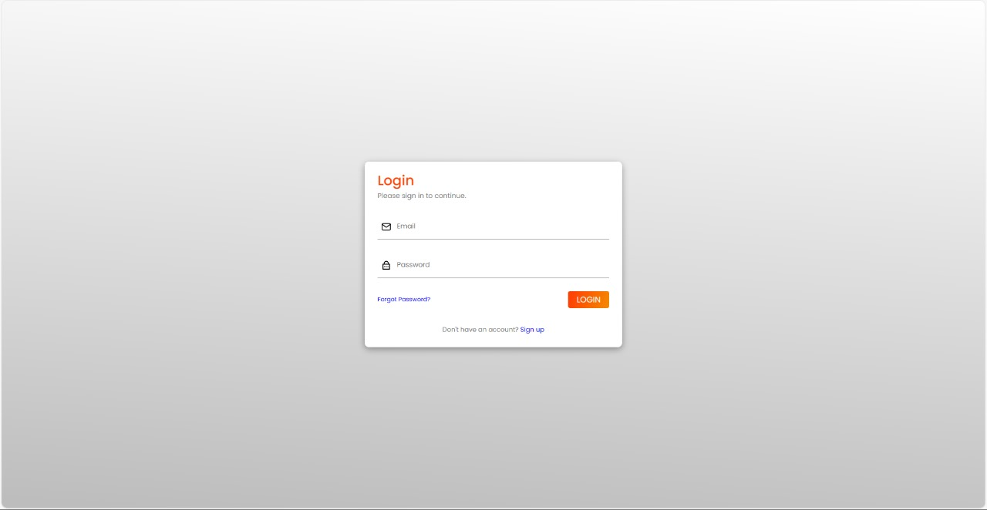

Login Page

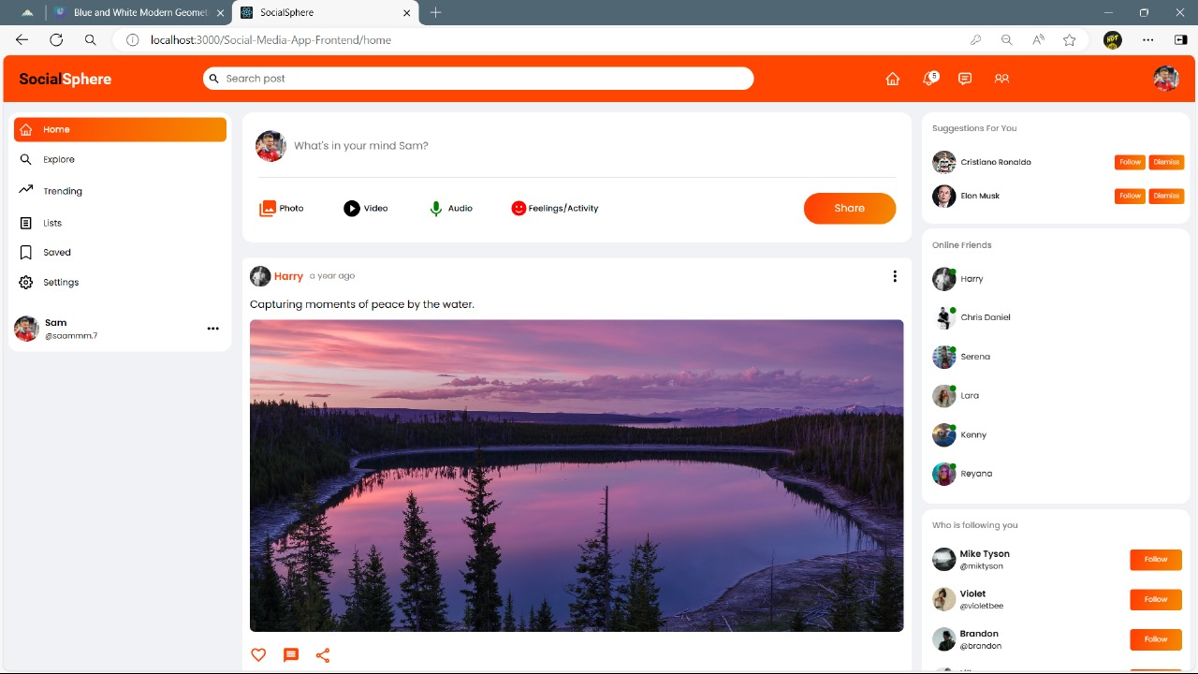

Home Page

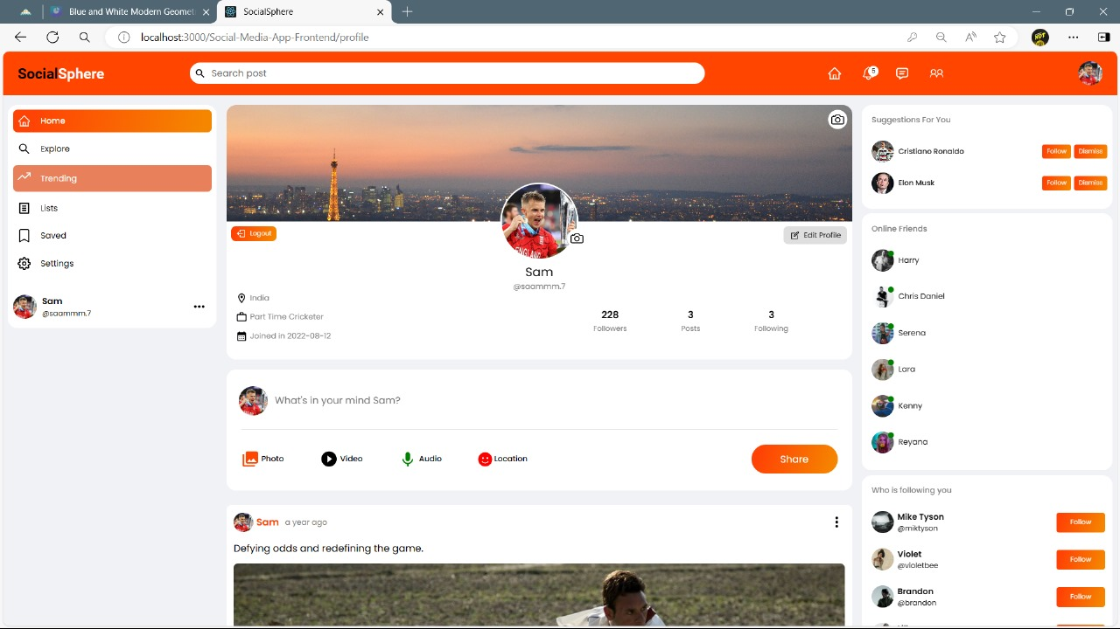

User’s Profile

1. **Conclusion**

In conclusion, the development and implementation of our social media app (SOCIAL SPHERE) represent a significant milestone in providing users with a dynamic and engaging platform for social interaction and content sharing. Through meticulous planning, iterative design, and agile development methodologies, we have successfully created an application that meets the diverse needs and expectations of our user base. The app's intuitive user interface, robust features, and seamless functionality offer users a compelling experience that fosters meaningful connections, facilitates content discovery, and promotes community engagement.

Furthermore, our commitment to privacy, security, and content moderation ensures a safe and respectful environment for users to interact and share content. Moving forward, we remain dedicated to enhancing the app's capabilities, addressing user feedback, and staying abreast of emerging trends and technologies to continue delivering a best-in-class social media experience. With a strong foundation in place, we are excited about the possibilities for future growth and innovation as we continue to evolve and refine our social media app to meet the evolving needs of our users.

1. **References**

* [**https://www.w3schools.com/react**](https://www.w3schools.com/react)
* [**https://www.mongodb.com**](https://www.mongodb.com/)
* [**https://github.com/aakasshhh**](https://github.com/aakasshhh)
* [**https://www.youtube.com**](https://www.youtube.com)